**NATIONAL CAPITAL BAPTIST CONVENTION OF WASHINGTON DC & VICINITY**

**NATIONAL CAPITAL CONGRESS OF CHRISTIAN EDUCATION**

**REV. DR. RAFE M. TAYLOR SCHOLARSHIP APPLICATION INSTRUCTIONS**

Before completing this application form, *please read all information related to Rev. Dr. Rafe M. Taylor Scholarship below. You must submit this completed application form and all supplementary sheets outlined in this application to National Capital Congress of Christian Education.* Please be sure to meet the application deadline. You should be prepared for a personal interview at the discretion of the scholarship committee.

# Application

Applications must be typed (in Roman alphabet, if possible). Do not use initials or abbreviations. The applicant should review his/her answers and essay carefully in order to prevent errors or omissions. The completed and typed application including the essay must be returned by **June 3, 2024**. *(Envelopes must be post marked no later than the due date).* Awards will be presented on **June 22, 2024,** at the NCBC Youth Explosion.

**Essay (***Required***)**

All applicants are required to submit a double-spaced and typed 500–750-word essay answering the statement: **Describe the impact Christian Education has had on your life, including your future goals and plans for achieving them.** Give particular care to your essay and avoid vague and general statements.

**Selection Criteria**

The Rev. Dr. Rafe M. Taylor Scholarship is provided to delegates from a NCBC constituent church currently in good standing with the National Capital Congress of Christian Education. The scholarship is intended to motivate students to actively participate in the work of the Congress. Recipients are selected based upon the following criteria:

1. Applicant must be a graduating high school senior who has been accepted into an institution of higher learning (college, university, trade school, etc.) or continuing student (college, university, trade school, graduate school etc.).
2. Applicant must be a member of a church currently in good standing with the Convention.
3. Applicant must submit a letter of recommendation from their Pastor.
4. Applicant must have participated during the year in at least 1 Congress events or other religious training. For other religious training/education, please submit a statement on official letterhead.
5. Applicant must complete and return the attached application and essay by the deadline. (Special attention will be given to the essay).
6. Applicant must produce a letter of acceptance to an institution of higher learning/trade school prior to receiving the award.
7. Applicant must submit two letters of recommendation from their school (administrator, teacher, and/or guidance counselor).
8. Applicant must submit a one-page minimum biography.
9. Applicant must have a grade point average of at least 2.5 or higher (on a 4.0 scale).

# Submission Inquiries

|  |  |
| --- | --- |
| **Return essay with completed application to:**  **By mail:**  Min. James Harris, Jr.  *Scholarship Coordinator*  6505 Elk Court  Waldorf. MD 20603  **By email:**  Jfharris2020@gmail.com  Subject Line: NCCCE 2023 Scholarship Application | Please refer all questions to:  James Harris, Jr  Telephone:  Email: jfharris2020@gmail.com |
|  |  |
|  |  |
|  |  |

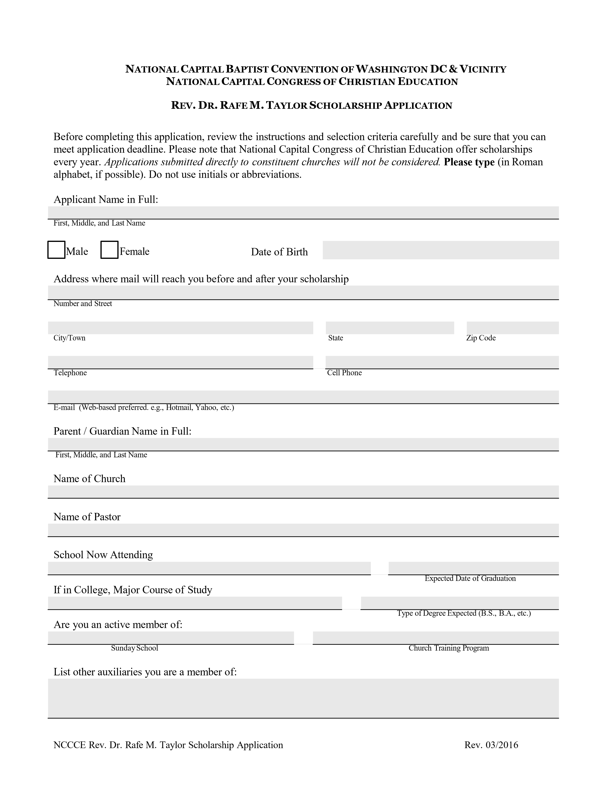



**N**

**ATIONAL**

**C**

**APITAL**

**B**

**APTIST**

**C**

**ONVENTION OF**

**W**

**ASHINGTON**

**DC & V**

**ICINITY**

**N**

**ATIONAL**

**C**

**APITAL**

**C**

**ONGRESS OF**

**C**

**HRISTIAN**

**E**

**DUCATION**

**R**

**EV**

**. D**

**R**

**. R**

**AFE**

**M. T**

**AYLOR**

**S**

**CHOLARSHIP**

**A**

**PPLICATION**

List Community, School, and other Activities participated in:

Have you participated in any of the following Congress Activities within the Past Year?

Applicant must have participated in some Congress, Youth and Young Adult Department activity or other

religious training. For other training, please submit a statement on Official Letterhead.

□

□

NBC-USA Annual Congress Session

□

NCBC DC & Vicinity Youth Dept. Activities (Specify):

□

Local Church Leadership School (Specify):

Other Related Activities/Trainings (list here)

**A

***required***

organized written (double-spaced) essay of 500-750 words to include:

**Describe the impact Christian Education has had on your life, including your future goals and plans for achieving them.**

**Please attach essay and biography to the completed application.**

Applicant Signature

Date (mm/dd/yyyy)

NCCCE Rev. Dr. Rafe M. Taylor Scholarship Application

Rev. 04/2024

NCBC DC & Vicinity Youth Dept. Activities (Specify):